Church Center Instructions
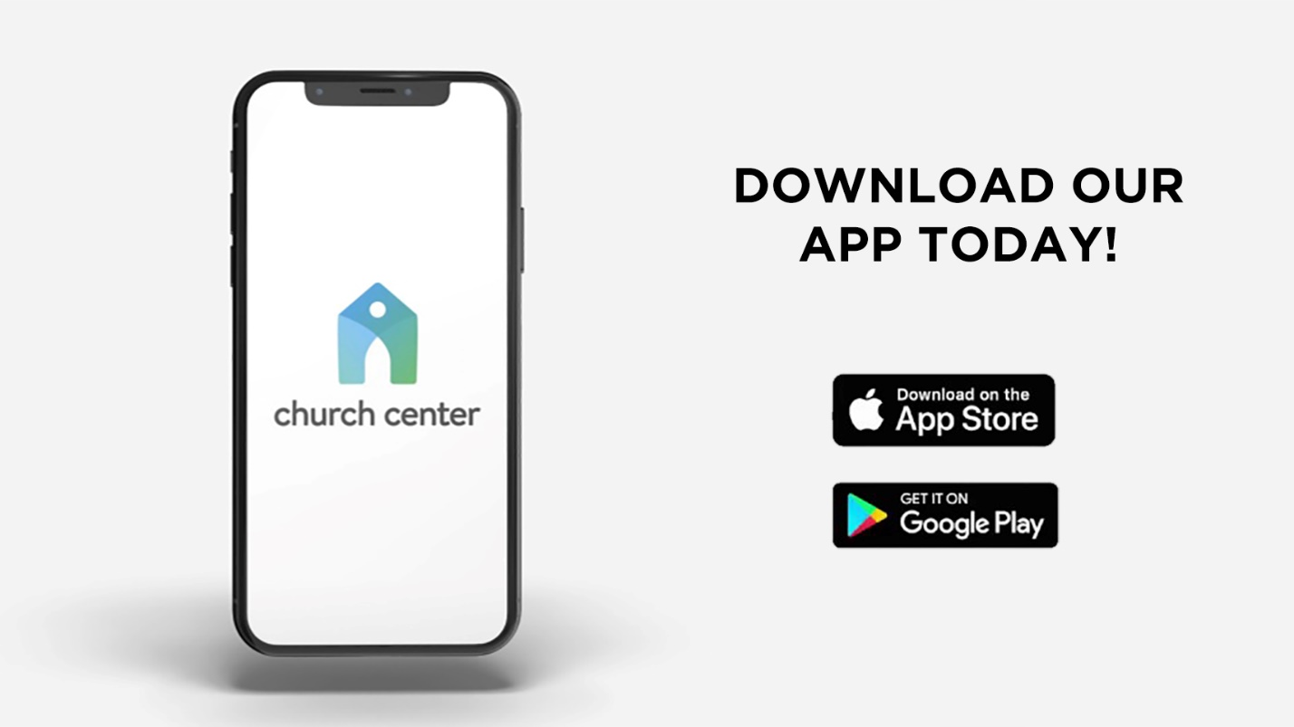

Church Center is the online or smartphone portal for our church family.
Your personal information IS NOT shared or available to anyone other than church staff unless you choose to participate in a group.
If you do not have a smartphone or do not want to use Church Center from your phone you can still access all the features from the Web portal.

Download and install the app:
- Search ‘Church Center’ in your app store
- Download and install
- Click on ‘Get Started’
- It will need to find our church so you can either:
  - Allow it to access your location & click ‘The Metropolitan Bible Church’’ OR
  - Don’t allow access and search for our church manually
- Click on our church logo and select, ‘This is my church’
- Enter your phone number
- Enter the login code that will be immediately texted to you
- Click on your user profile to log in (Don’t worry…these steps are just to set up the app. You won’t have to do this every time!)

